**Q 2. Which platform is the most effective (average engagement) for each industry?**

In order to find the most effective platform for each industry, we used the customer/prospect engagement rate for each company’s social media profile across all the social media platforms that a company uses for its marketing. It eventually became clear that some platforms had a higher engagement rate than others for different industries. There were five social media marketing platforms which we considered for each company – Youtube, Twitter, Instagram, TikTok and Facebook.

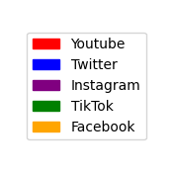

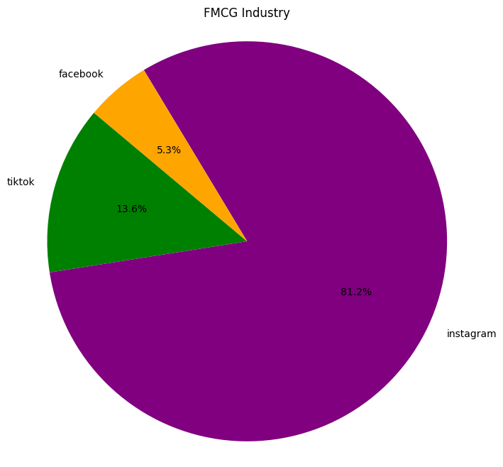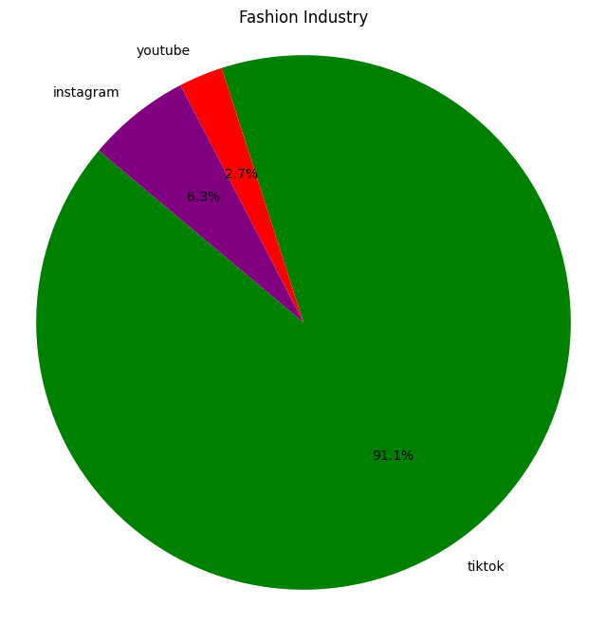

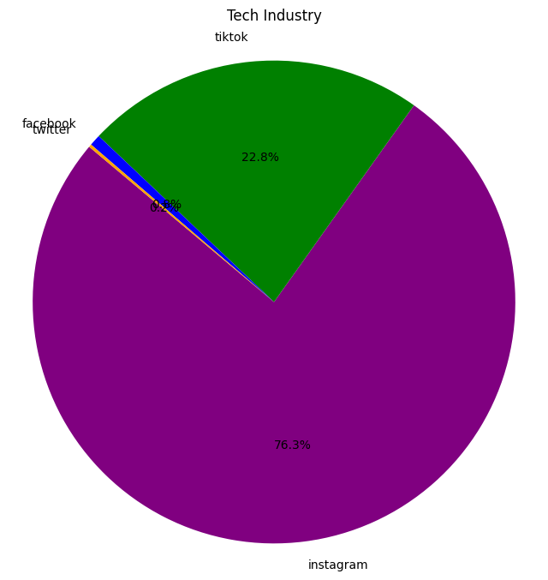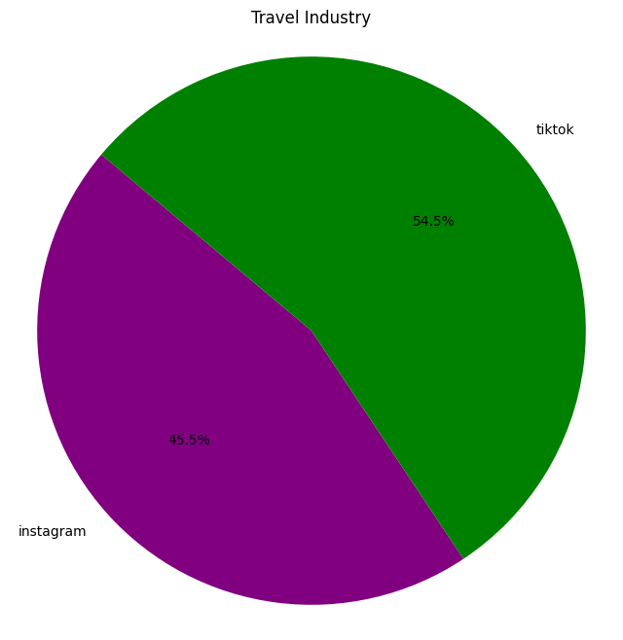

The pie charts above represent the share of companies in each industry that recorded their highest engagement rate on a particular platform. For instance, in the FMCG industry, Instagram had the highest engagement rate for 81.2% of the companies. Tiktok had the highest engagement rate for 13.6% of the companies while Facebook had the highest engagement rate for 5.3% of the companies. Since the frequency of Instagram appearing as the platform with the highest engagement was the highest across all the companies in the FMCG industry, we consider it to be the most effective platform for that industry.

First, for every company in each industry, we identified the social media platform on which that specific company enjoys the highest engagement rate as compared to the other social media platforms that the company uses for marketing. We now had a collection of each company in an industry and its corresponding platform with the highest engagement rate. We then proceeded to count the number of times each platform emerged as the platform with the highest engagement rate for that industry. We saw that for each industry, there was always one platform which performed better than the other overall, across the companies in that industry.

This approach allows us to not go solely by percentages and numbers telling us the engagement rate on each platform. It allows us to view the qualitative productivity and effectiveness of that platform in comparison to the other platforms that a company uses. It ultimately tells us which platform in a given industry, has the highest frequency across all companies in that industry, to emerge as the most effective platform as compared to the other platforms that a company used.

Overall, it appears that Instagram is the most effective platform across the FMCG industry in terms of its customer engagement potential. Similarly, Instagram is also the most effective platform, overall , for the Tech industry. Tiktok emerged as the most effective platform for the Travel and Fashion industries.